Making time for mindfulness at home can have a noticeable impact on your child’s wellbeing. These strategies will help your child put it into practice in their everyday life.
Mindfulness at Home

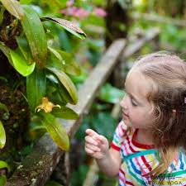
- Go for a mindful walk. Have a stroll around your neighbourhood, the local park or the woods, making an effort to spot things you haven’t noticed before. During the walk, stop for a minute and concentrate only on the things you can hear: an easy exercise in mindfulness.

- Make a mindfulness jar. Fill a jar almost to the brim with water, tip in some glitter, and fasten the lid firmly. Your child can then shake the jar and focus on what happens as the glitter swirls and then settles.

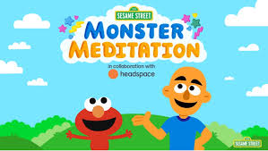

- Help children learn to manage their emotions by using mindfulness techniques. Headspace has partnered with Sesame Street to produce animated short films called Monster Meditations, available for free on YouTube, featuring Cookie Monster, Elmo and Grover. The characters experience frustration, impatience, nervousness, disappointment and excitement and learn how breathing and sensory activities can help them with everyday feelings.
- Blow bubbles. This is a great way to focus on breathing: a key part of mindfulness practice. Encourage your child to make the biggest bubble they can and notice how they have to blow slowly and steadily to make it happen.

- Use a mindfulness app. There are lots of good apps that help children master mindfulness, including Headspace for Kids, Smiling Mind and Sleep Meditations for Kids. Apps are great for children to do in their free time, but don’t impose them on your child.

J.Herron
Health and Wellbeing Co-ordinator
14.12.20

