#GrowingUpBetterTogether

Activity workbook & toolkit

For Adults supporting Children’s
Mental Health & Emotional Wellbeing

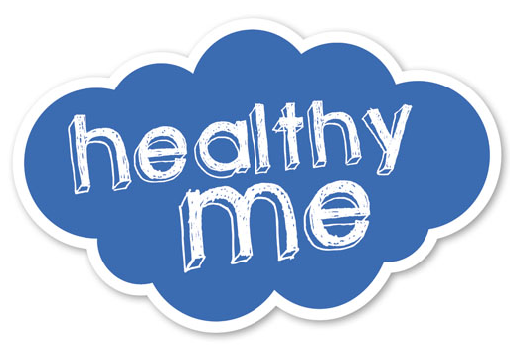

Who are OUR Generation?
OUR Generation is an EU PEACE IV funded project that provides a unique opportunity for communities, across Northern Ireland and the Border Regions of Ireland, to work together to halt the intergenerational impact of trauma and to build emotional resilience and peace for generations to come. The Project is match-funded by the Executive Office in Norther Ireland and the Department of Rural and Community Development in Ireland.
A project supported by the European Union's PEACE IV Programme, managed by the Special EU Programmes Body (SEU PB).

http://bit.ly/OGLaunchRSVP

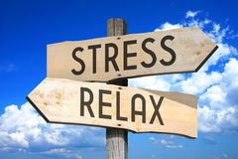
Stress Questionnaire

Because everyone reacts to stress in his or her own way, no one stress test can give you a complete diagnosis of your stress levels.
This stress test is intended to give you an overview only. Please see a Stress Management Consultant for a more in depth analysis.
Answer all the questions but just tick one box that applies to you, either yes or no. Answer yes, even if only part of a question applies to you.
Take your time, but please be completely honest with your answers:

 |  | Yes | No
1 | I frequently bring work home at night
2 | Not enough hours in the day to do all the things that I must do
3 | I deny or ignore problems in the hope that they will go away
4 | I do the jobs myself to ensure they are done properly
5 | I underestimate how long it takes to do things
6 | I feel that there are too many deadlines in my work / life that are difficult to meet
7 | My self-confidence / self-esteem is lower than I would like it to be
8 | I frequently have guilty feelings if I relax and do nothing
9 | I find myself thinking about problems even when I am supposed to be relaxing
10 | I feel fatigued or tired even when I wake after an adequate sleep
11 | I often nod or finish other peoples sentences for them when they speak slowly
12 | I have a tendency to eat, talk, walk and drive quickly
13 | My appetite has changed, have either a desire to binge or have a loss of appetite / may skip meals
14 | I feel irritated or angry if the car or traffic in front seems to be going too slowly/ I become very frustrated at having to wait in a queue
15 | If something or someone really annoys me I will bottle up my feelings
16 | When I play sport or games, I really try to win whoever I play
17 | I experience mood swings, difficulty making decisions, concentration and memory is impaired
18 | I find fault and criticize others rather than praising, even if it is deserved
19 | I seem to be listening even though I am preoccupied with my own thoughts
20 | My sex drive is lower, can experience changes to menstrual cycle
21 | I find myself grinding my teeth
22 | Increase in muscular aches and pains especially in the neck, head, lower back, shoulders
23 | I am unable to perform tasks as well as I used to, my judgment is clouded or not as good as it was
24 | I find I have a greater dependency on alcohol, caffeine, nicotine or drugs
25 | I find that I don’t have time for many interests / hobbies outside of work

Your score:
A yes answer score = I (one), and a no answer score = 0 (zero).
TOTALS
Most of us can manage varying amounts of pressure without feeling stressed. However too much or excessive pressure, often created by our own thinking patterns and life experiences, can overstretch our ability to cope and then stress is experienced.
4 points or less: You are least likely to suffer from stress-related illness.
5 - 13 points: You are more likely to experience stress related ill health either mental, physical or both. You would benefit from stress management / counselling or advice to help in the identified areas.
14 points or more: You are the most prone to stress showing a great many traits or characteristics that are creating un-healthy behaviours. This means that you are also more likely to experience stress & stress-related illness e.g. diabetes, irritable bowel, migraine, back and neck pain, high blood pressure, heart disease/strokes, mental ill health (depression, anxiety & stress). It is important to seek professional help or stress management counselling. Consult your medical practitioner.
Tips to help improve your score
Review the questions that you scored yes:
- Is this a problem that I need to address
- Can I do something about it myself
- See if you can reduce, change or modify this trait.
- Start with the ones that are easiest & most likely to be successful for you.
- Only expect small changes to start with, it takes daily practice to make any change.
- Do I need some help or support to make this change
- Support from friends, family/colleagues will make the process easier and more enjoyable.
- Professional help is always available & your GP is a good place to start
- Check out the top 10 tips to manage build your resilience in this booklet

Stress test adopted from © International Stress Management Association UK – 2013

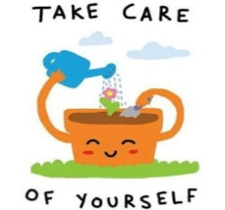
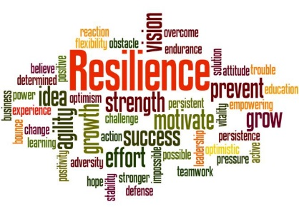

Top Ten Stress Busting Tips

1. Learn to manage your time more effectively
We waste a lot of time doing unimportant tasks, especially when stressed, so prioritise your day and do the important jobs first. The unimportant ones can wait, and often they will disappear completely leaving you time to do other things. Also, do not put off the unpleasant tasks – avoidance causes a great deal of stress. Give unpleasant tasks a high priority and do them first.

2. Adopt a healthy lifestyle
If we eat a healthy diet, exercise regularly and ensure we get adequate sleep and rest our body is better able to cope with stress should it occur If this is not the case, then this may be a warning sign so don’t ignore it.
Engaging in some form of physical activity may help you by working off the biochemical and physical changes that occur within your body due to stress. Relaxation also helps your body return to its normal healthy state. Good relaxation techniques include breathing exercises, massage and a variety of complimentary therapies.

3. Know your limitations and do not take on too much
We can cause ourselves a great deal of stress because we do not want to let people down. We then end up doing more than we should. Learn to delegate effectively and be assertive so that you can say ‘No’ without upsetting or offending.

4. Find out what causes you stress
Take time to discover what is worrying you and try to change your thoughts and behaviour to reduce it. A stress assessment can help you to fully understand the causes, the implications to your health and how to manage, cope and make necessary changes.

5. Avoid unnecessary conflict
Do not be too argumentative. Is it really worth the stress? Look for win - win situations. Look for a resolution to a dispute where both parties can achieve a positive outcome. Find out what the real cause of the problem is and deal with it.

6. Accept the things you cannot change
Changing a difficult situation is not always possible. If this proves to be the case, recognise and accept things as they are and concentrate on all that you do have control over. Managing change effectively is essential or else performance will be reduced.

7. Take time out to relax and recharge your batteries
You will perform more effectively during work if you regularly take a short 10 / 15 minute break, easily making up the time you used relaxing. Alongside this, at least one annual break of at least 10-14 continuous days is recommended.

8. Find time to meet friends
Friends can ease work troubles and help us see things in a different way. The activities we engage in with friends help us relax and we will often have a good laugh. It boosts the immune system that is often depleted during stress.

9. Try to see things differently, develop a positive thinking style
If something is concerning you, try to see it differently. Talk over your problem with somebody before it gets out of proportion. Often, talking to a friend/colleague/family member will help you see things from a different and less stressful perspective. You may also need to consider professional help in order to achieve the desired outcome and prevent ill health and / or burnout.

10. Avoid alcohol, nicotine and caffeine as coping mechanisms
Long term, these faulty coping mechanisms will just add to the problem. For example, caffeine and nicotine are stimulants – too much and the body reacts to this with the stress response increasing or even causing anxiety symptoms. Alcohol is a depressant!

A – Z of self-care
Choose a wellbeing strategy for each letter of the alphabet

A |  | N
B |  | O
C |  | P
D |  | Q
E |  | R
F |  | S
G |  | T
H |  | U
I |  | V
J |  | W
K |  | X
L |  | Y
M |  | Z

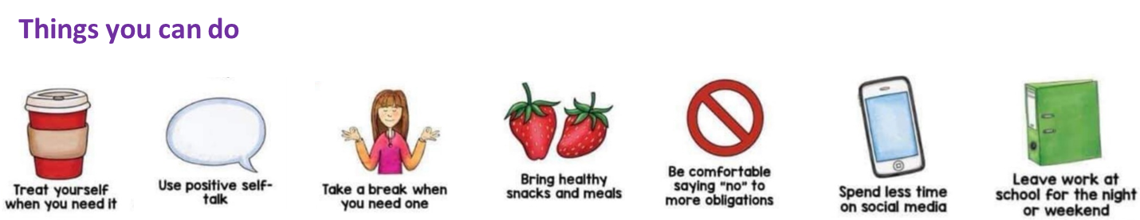

Uplifting Activities

Connect with Others

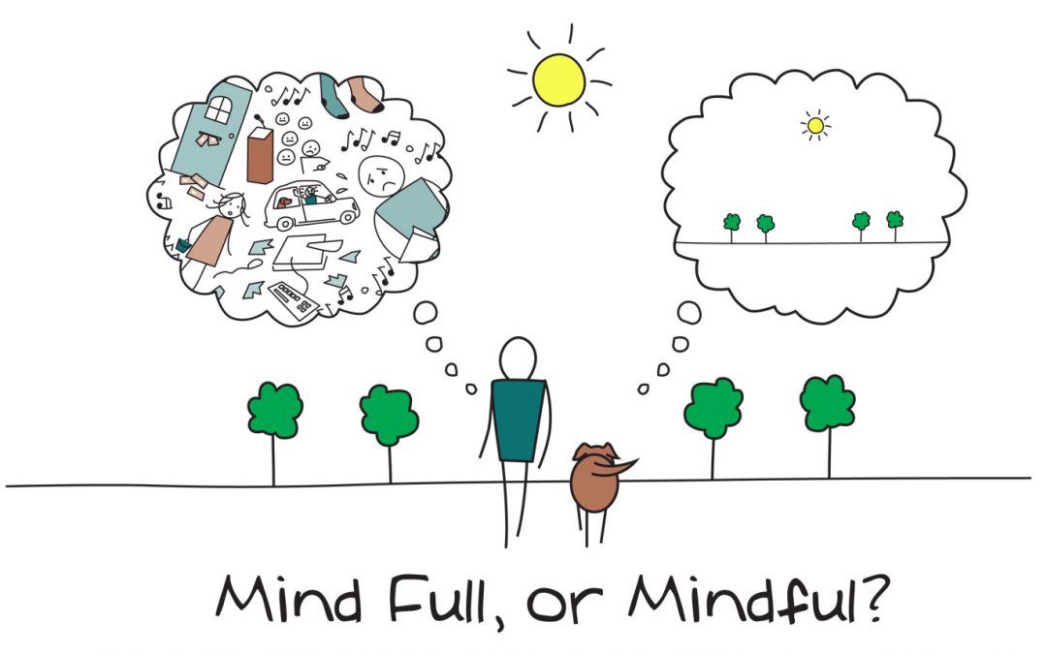
Simple grounding technique
Feeling anxious, worried, overwhelmed or scared bring your attention back to the current moment with this simple grounding exercise. Notice:
5 things you can SEE
4 things you can HEAR
3 things you can FEEL
2 things you can SMELL (or recall your favourite smells)
1 thing you can TASTE (or recall your favourite taste)
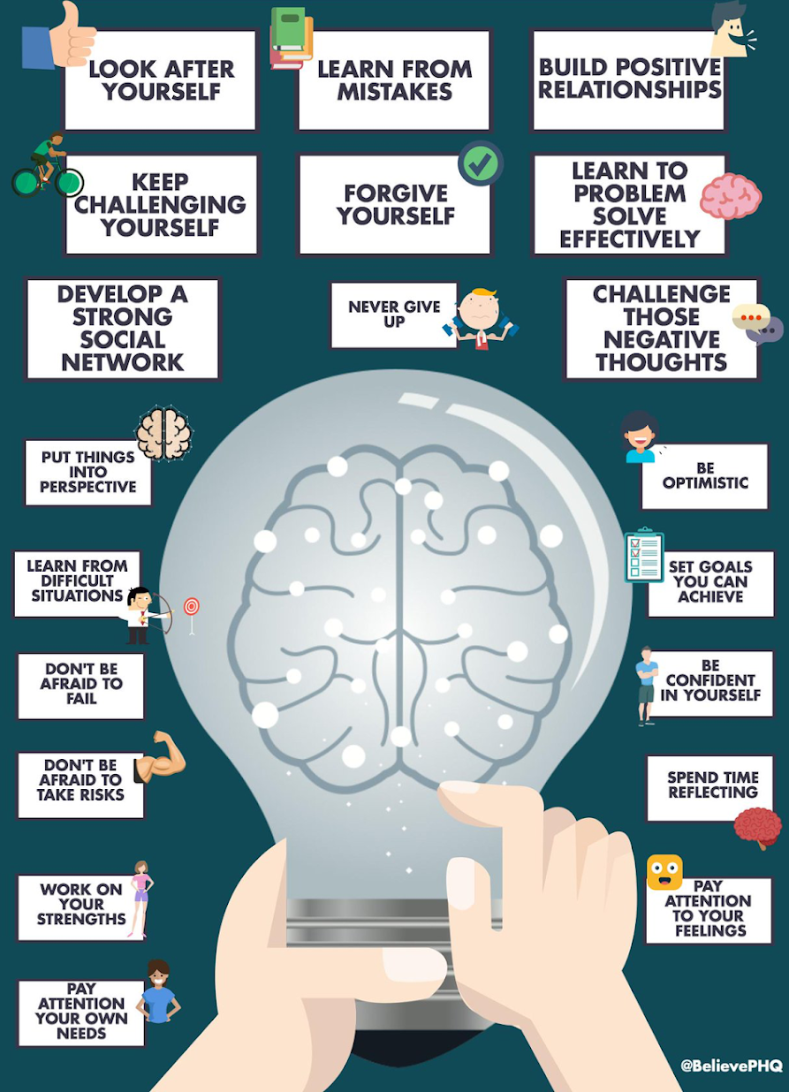

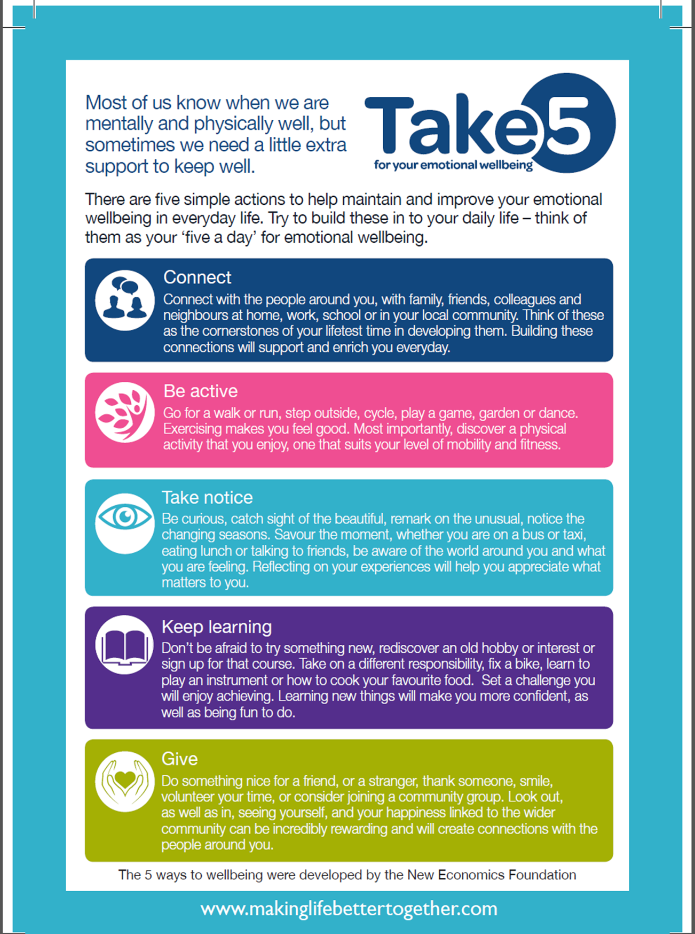

5 Ways to Wellbeing Diary
 | Monday | Tuesday | Wednesday | Thursday | Friday | Saturday | Sunday
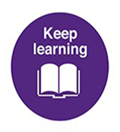

How are you taking 5? Record your activity or strategy for each of the 5 ways each day. Remember 1 activity could cover several
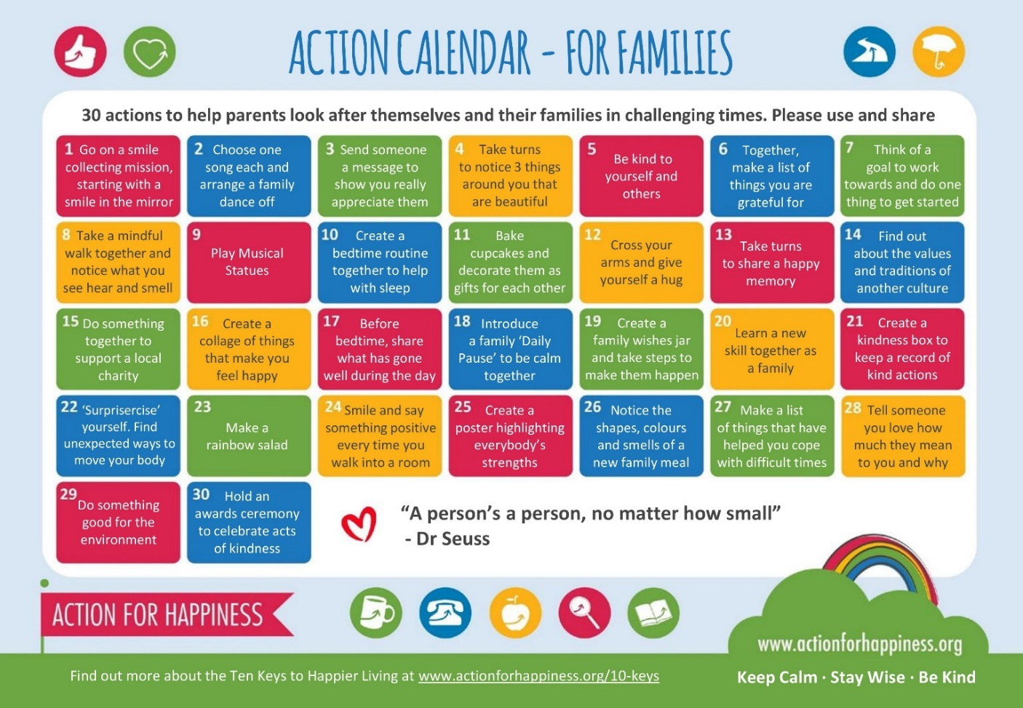

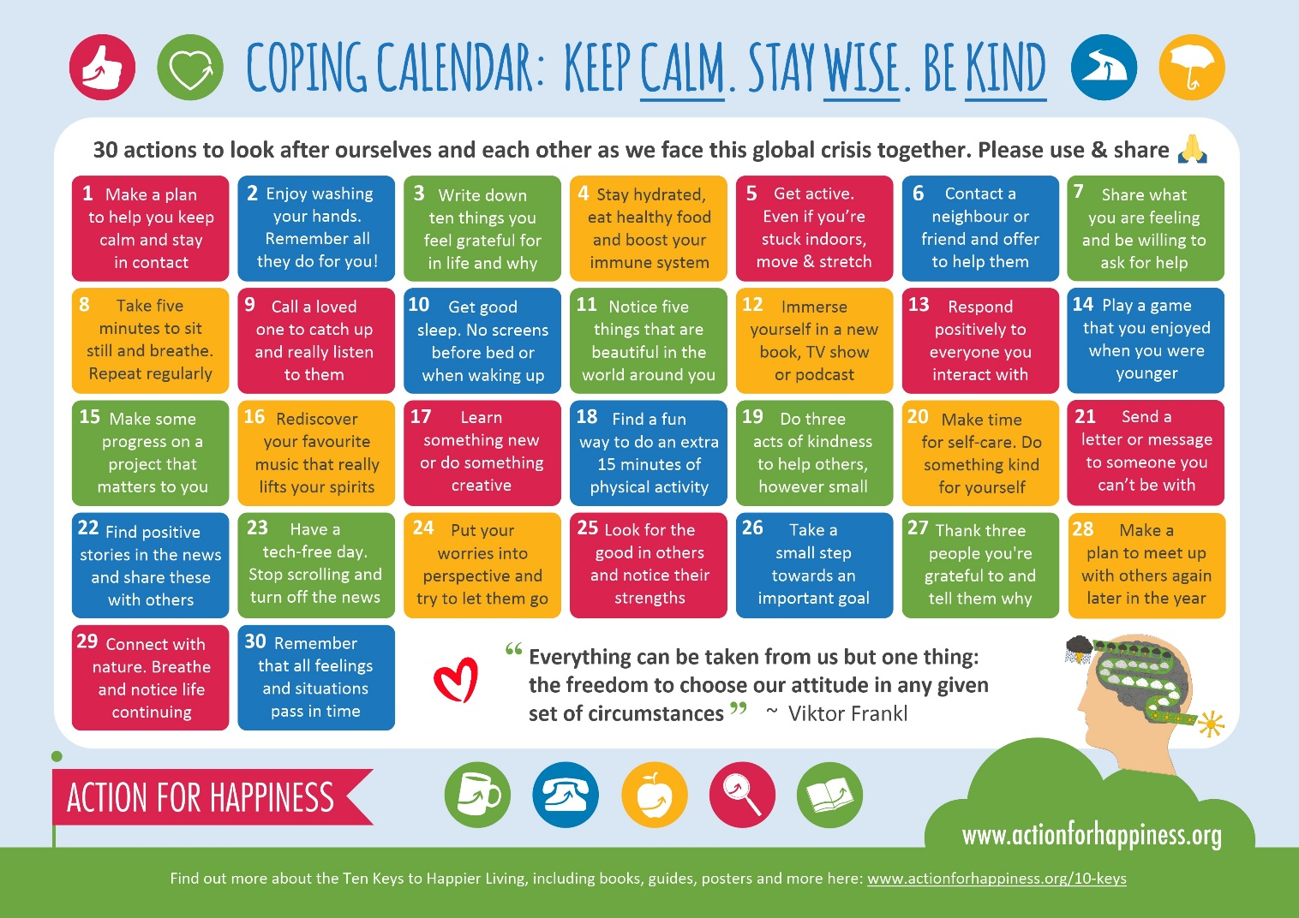
Personal & Family Support Organisations in Northern Ireland
Websites & Apps for Android & i-phone
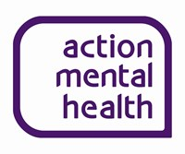
www.amh.org.uk/services/resources-for-children-and-young-people

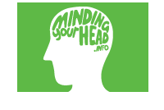
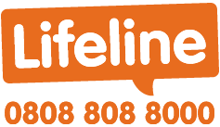

www.amh.org.uk/new-life-counselling www.mindingyourhead www.lifelinehelpline.info
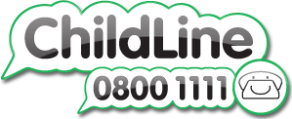

www.zestni.org/services www.samaritans.org www.childline.org.uk
www.actionforchildren.org.uk www.parentingni.org www.cypsp.org
www.parentingni.org

www.man-ni.org
www.womensaidni.org

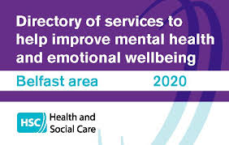
www.acamh.org

https://www.publichealth.hscni.net/publications/directory-services-help-improve-mental-health-and-emotional-wellbeing

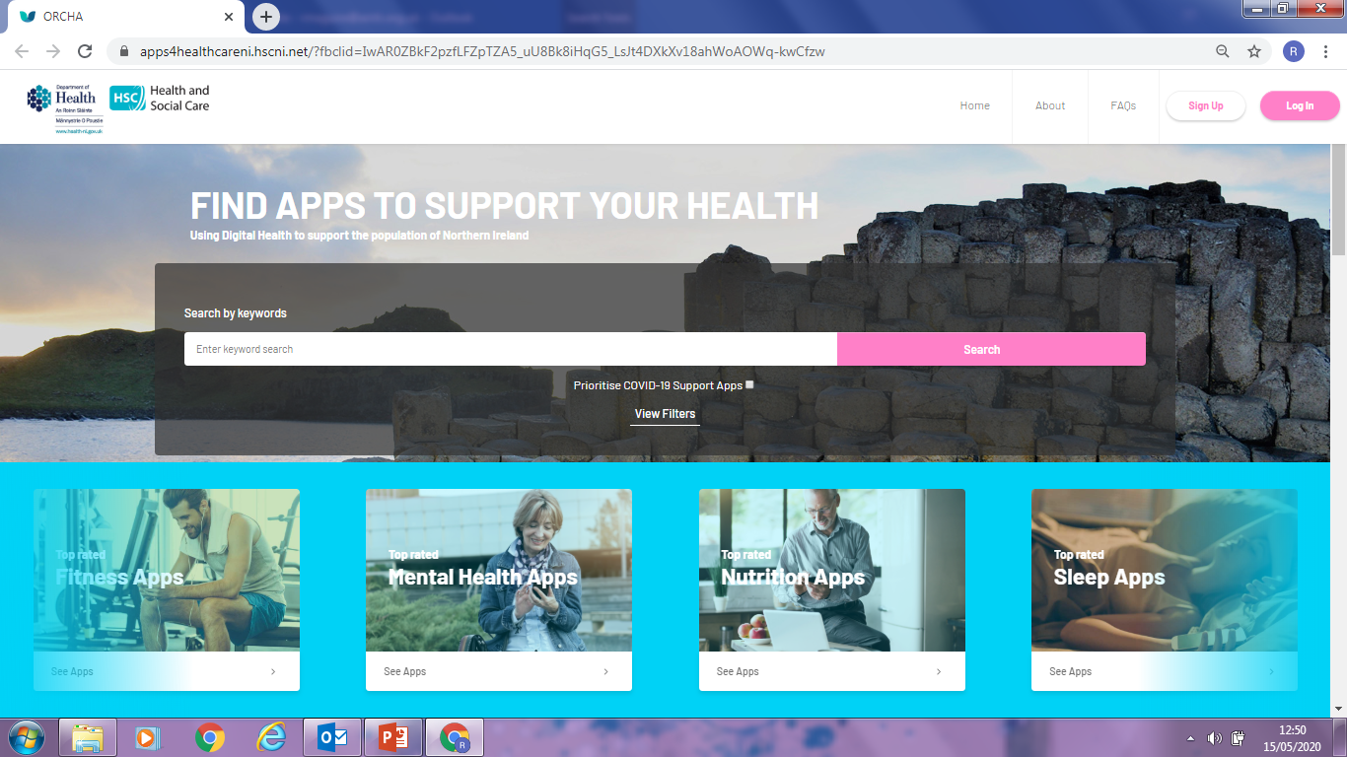
https://apps4healthcareni.hscni.net

Hear2Help
It's free to download and contains contact information for people living in Northern Ireland and reading material for people who find themselves struggling with everything from substance abuse and suicidal thoughts, to coping with bereavement and advice on claiming benefits.

Stay Alive
The Stay Alive app is a suicide prevention resource for the UK, packed full of useful information and tools.
Silver Cloud
Silver Cloud is a free 8 week online course to help you manage stress, anxiety and depression.

Catch it
Learn how to manage feelings like anxiety and depression with Catch It. The app will teach you how to look at problems in a different way, turn negative thoughts into positive ones and improve your mental wellbeing.

distrACT
The distrACT app gives you easy, quick and discreet access to information and advice about self-harm and suicidal thoughts. The content has been created by doctors and experts in self-harming and suicide prevention.

eQuoo: Emotional Fitness Game
The eQuoo app uses adventure games designed by psychologists to help you increase your emotional fitness and teach you new psychological skills.

Student Health App

The Student Health App provides easy access to more than 900 pages of reliable health information all in one place. The content has been created for university students by NHS doctors and is regularly updated.
Use the app to reduce your worries, feel more confident and get the support you need at what can be a challenging time for any student

ThinkNinja
Free during the coronavirus (COVID-19) crisis
ThinkNinja is a mental health app designed for 10 to 18 year olds. Using a variety of content and tools, it allows young people to learn about mental health and emotional wellbeing, and develop skills they can use to build resilience and stay well.

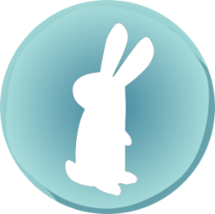
MoodSpace
Stress, anxiety, & low mood self-help

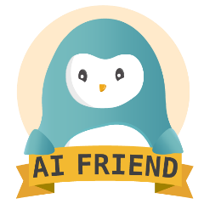
Wysa

Stress, sleep & mindfulness therapy chatbot
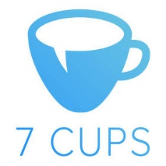
7 Cups
A website which provides online therapy and free support to people experiencing emotional distress by connecting them with trained listeners.

Moodtools- depression aid
If you are feeling sad, anxious, or depressed, lift your mood with MoodTools! MoodTools is designed to help you combat depression and alleviate your negative moods, aiding you on your road to recovery.

Fear tools- Anxiety app
FearTools is an evidence-based app designed to help you combat anxiety, aiding you on your road to recovery. This application is especially useful for those suffering from Generalized Anxiety Disorder, Phobias, and Social Anxiety Disorder.

